MCSL Lab05

7-Seg LED

0410001

Hong-Shuo Chen

1. Experiment Purpose

* Understand the principle of MAX7219
* Design the program of the 7-Seg LED

1. Background theory

Please refer to the lecture and lab5_note

1. Experiment Procedure

3.1. Lab5.1: practice of Max7219 and 7-Seg LED

– without code B decode mode

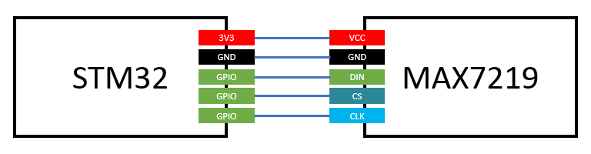

Connect 3.3V and GND pin on STM32 to VCC and GND port on MAX7219. Choose three GIPO ports on STM32 for DIN, CS and CLK on MAX7219.

Complete the code giving below and display 0, 1, 2, 3…, 9, A, b, C, d, E, F to the first digit of 7-Seg LED at 1 second interval. Example video link is giving above.

<https://goo.gl/ZDZcdl>

Note: Due to the fact that decode mode is unable to display alphabets, please disable decode mode(ref: lab5_note table 6).

.syntax unified

.cpu cortex-m4

.thumb

.data

arr: .byte 0x0, 0x0, 0x0, 0x0, 0x0, 0x0, 0x0, 0x0, 0x0, 0x0, 0x0, 0x0, 0x0, 0x0, 0x0, 0x0 //TODO: put 0 to F 7-Seg LED pattern here

.text

.global main

main:

BL GPIO_init

BL max7219_init

loop:

BL Display0toF

B loop

GPIO_init:

//TODO: Initialize three GPIO pins as output for max7219 DIN, CS and CLK

BX LR

Display0toF:

//TODO: Display 0 to F at first digit on 7-SEG LED. Display one per second.

BX LR

MAX7219Send:

//input parameter: r0 is ADDRESS , r1 is DATA

//TODO: Use this function to send a message to max7219

BX LR

max7219_init:

//TODO: Initialize max7219 registers

BX LR

Delay:

//TODO: Write a delay 1sec function

BX LR

3.2. Lab5.2: practice of Max721 and 7-Seg LED

– use code B decode mode

Using GPIO output to display your student ID on 7-Seg LED. Picture above is showing the case that your student ID is 1234567.

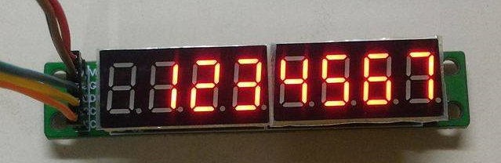

Complete the code giving below. Put your student ID in student_id array and display it to 7-Seg LED.

Note: Please enable decode mode.

.syntax unified

.cpu cortex-m4

.thumb

.data

student_id: .byte 1, 2, 3,4, 5, 6, 7 //TODO: put your student id here

.text

.global main

main:

BL GPIO_init

BL max7219_init

//TODO: display your student id on 7-Seg LED

Program_end:

B Program_end

GPIO_init:

//TODO: Initialize three GPIO pins as output for max7219 DIN, CS and CLK

BX LR

MAX7219Send:

//input parameter: r0 is ADDRESS , r1 is DATA

//TODO: Use this function to send a message to max7219

BX LR

max7219_init:

//TODO: Initial max7219 registers.

BX LR

3.3. Lab5.3 practice of Max7219 and 7-SEG LED

- display Fibonacci

Design a program to detect user button on STM32 pressed. When user button is pressed N times, display fib(N) on 7-Seg LED. When user button is held down for 1 second, set displayed number to 0. Example video link is given above.

<https://goo.gl/6DF6eY>

fib(0) = 0, fib(1) = 1, fib(2) = 1, ……

if fib(N) ≥ 100000000 then display -1.

Note: Please remember to deal with the bouncing problem.

1. Results and Discussion

4.1. Lab5.1: practice of Max7219 and 7-Seg LED

– without code B decode mode

Hardware Design:



I use PA5 as DIN, PA6 as CS and PA7 as CLK.

Code Explanation:

There are three main parts in the first lab. The first part is GPIO_init, because I use the GPIOA, so I need to set these ports as output and high speed mode. We later use BSRR and BSR to control these GPIO port.

The second part is max7219_init. Decode mode cannot display some alphabets. So we use no-decode mode. Moreover, I set DISPLAY_TEST as 0, INTENSITY as A and SCAN_LIMIT as 0. Because we only need to use one word.

The last part is display the number. When I display one number, I delay for one second, and display the next number in the array.

The max7219_send is the most important part in this lab. I wrote it by referring to the lecture.

4.2. Lab5.2: practice of Max7219 and 7-Seg LED

– use code B decode mode

Hardware Design:

Same as Lab5.1

Code Explanation:

GPIO_init is same as the Lab5.1. I change the SCAN_LIMIT to 6. Because the student id is seven numbers. I just use the decode mode. So I set the DECODE_MODE as 0xFF, which means all the LEDs from D0 to D7 are DECODE_MODE.

4.3. Lab5.3 practice of Max7219 and 7-SEG LED

- display Fibonacci

Hardware Design:

Same as Lab5.1

Code Explanation:

This code is very complex. I want to explain it with five parts.

GPIO_init:

Almost same as Lab5.2, but there is an input PC13. We need to initialize more.

Max7219_init: Same as Lab5.2

Debounce:

There are two states in my code, which respectively are current state and last state. When the input is different from the last state, I wait for a period of short time, and check if the input is still different from the current state. If it is still different from the current state, we change the current state. Else, we just wait for the next input, which is different from the last state.

I use a counter to implement the long push. When we push the over a period of time, the counter will add up. When the counter is over a value, the LED will reset.

Fib: This is the algorithm of my code presenting by C++

int fib(int N){

int fib = f0 = 0;

int f1 = 1;

if (N == 0)

return 0;

else if (N == 1)

return 1;

else{

for(int i = 1; i < N; i++){

fib = f1 + f0;

f0 = f1;

f1 = fib;

}

return fib;

}

}

Display:

I use Lab5.2, but modify a little. I need to choose the first number, which is not zero and set it. Because we don’t want all the zero display on the 7-seg LED.

1. Reviews and Applications

This Lab needs some time to figure out the principle of MAX7219. It is a really a simple IC chip. However, can save us lots of time. This is the last Lab we use assembly. It is really a lab which I want to keep in mind. Assembly is really a basic language. A simple function may need lots of instructions. Sometimes it totally over my head. Fortunately, the lecture explain some concept nicely and with some example. For me it is really a nice experience to use assembly language. Also thanks a lot. I learn very much.